PEMBROKESHIRE YACHT CLUB
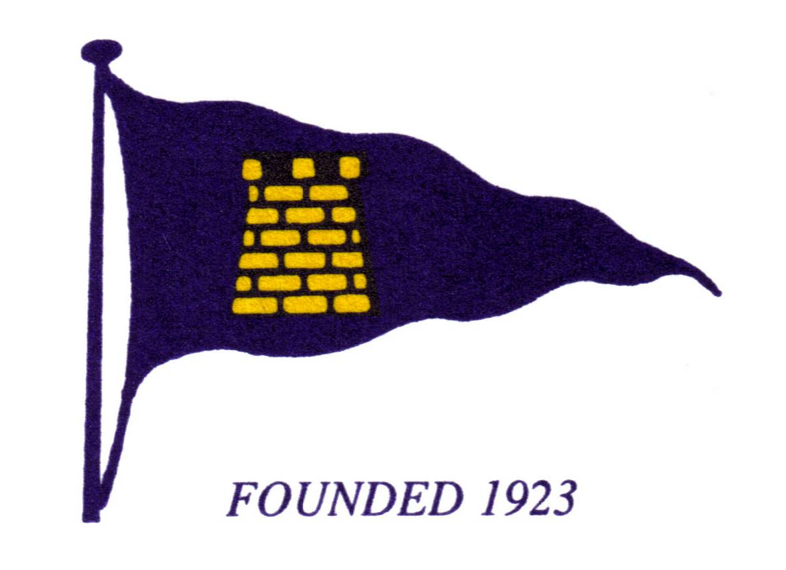

Headquarters:
GELLYSWICK BAY, HAKIN, MILFORD HAVEN, PEMBROKESHIRE, SA73 3RS
Tel: 01646 692799

16th January, 2024.

Part-time Bar Staff required at Pembrokeshire Yacht Club

PYC are currently seeking to recruit extra members of bar staff on a part-time basis to join a friendly team of staff and volunteers.
Applicants must be confident and self motivated as they will in most cases, be required to operate the bar single handed during their shift period.

Successful applicants will be required to join a small team of staff whose primarily role will be to provide a good and friendly service with respect to the operation and organisation of a Water Sports & Social Members Club bar.

The successful applicants will be required join the pool of part-time staff to primarily cover either Saturday and/or Sunday from 3pm until close, along with some other hours to cover staff holidays as required, on an agreed and rotational basis.

Remuneration: PYC pay all staff monthly in arrears on an hourly basis. Pay rates are in accordance with Government Policy for a “living wage” plus accrued holiday pay.
Previous experience in the hospitality or retail trade would be beneficial, however, each application will be considered on its own merits and training will be given where required.

If you wish to discuss in more detail the requirements of this vacancies, please contact Christian Smart in the first instance via email smartrimmer@aol.com.

Initial applications shall be in writing via email.
Applicants should provide basic personal and contact details which should include an address and mobile telephone number together with a brief resume of their previous experience.

----------------------------------------------------

