PEMBROKESHIRE YACHT CLUB
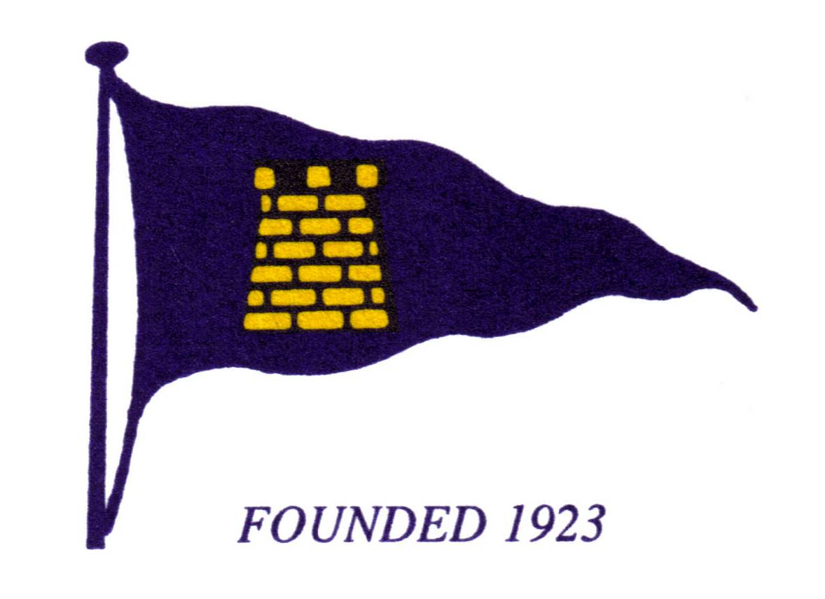

Headquarters:

GELLYSWICK BAY, HAKIN, MILFORD HAVEN, PEMBROKESHIRE. SA73 3RS. Tel: 01646 692799

Opening Hours:

April 4th to October 2nd 2022

These times may change due to demand, bookings or restrictions due to ongoing building works, but notice of any changes will be given via our Facebook, Website and email outlets in due course.

Booking for events / functions can be made anytime by contacting Christian via smartrimmer@aol.com or 07966 505767

MONDAY CLOSED

TUESDAY 6pm - CLOSE

WEDNESDAY 6pm – CLOSE

THURSDAY 6pm – CLOSE

FRIDAY 6pm – CLOSE

SATURDAY 3pm – CLOSE
(from April 16th)

SUNDAY 3pm - CLOSE

